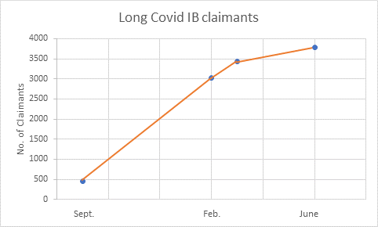

**Graph 2: Claimants on Enhanced Illness Benefit (Covid) for more than 10 weeks who transferred over to standard Illness Benefit**